Google Big Query

|  |  |
| --- | --- |
| **Summary** | Setting up an account on Google cloud. Using Google Big Query, explored the data and ran SQL Queries on dataset |
| **URL** | <https://console.cloud.google.com/bigquery>  <https://console.cloud.google.com/marketplace/product/obfuscated-ga360-data/obfuscated-ga360-data?filter=solution-type:dataset&q=analytics&project=level-elevator-303319&supportedpurview=project>  <https://colab.research.google.com/github/GoogleCloudPlatform/training-data-analyst/blob/master/blogs/babyweight/babyweight.ipynb#scrollTo=TCE9sDmHIIvm>  <https://support.google.com/analytics/answer/4419694?hl=en>  <https://cloud.google.com/solutions/machine-learning/ml-on-structured-data-analysis-prep-1>  <https://colab.research.google.com/github/GoogleCloudPlatform/training-data-analyst/blob/master/blogs/babyweight/babyweight.ipynb#scrollTo=3_45V-rAJMsX>  <https://github.com/GoogleCloudPlatform/training-data-analyst/tree/master/blogs/babyweight> |
| **Tools** | Google Big Query |

New Project Setup

Exploring Dataset

SQL Queries

3 Lesson Learned

# **Google Big Query New Project Setup**

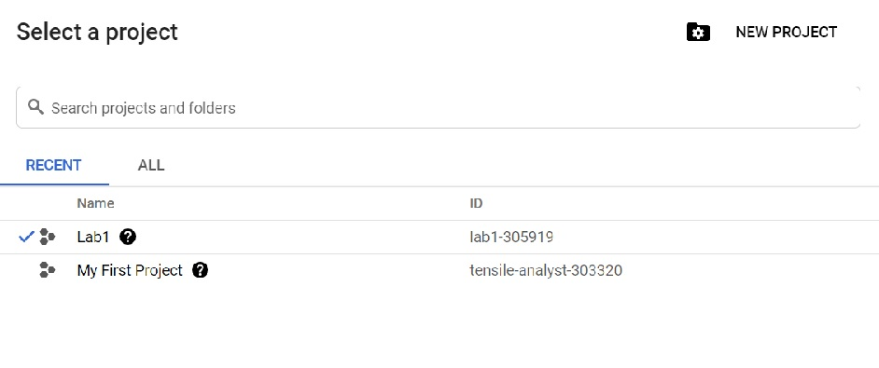

# **Exploring Dataset**

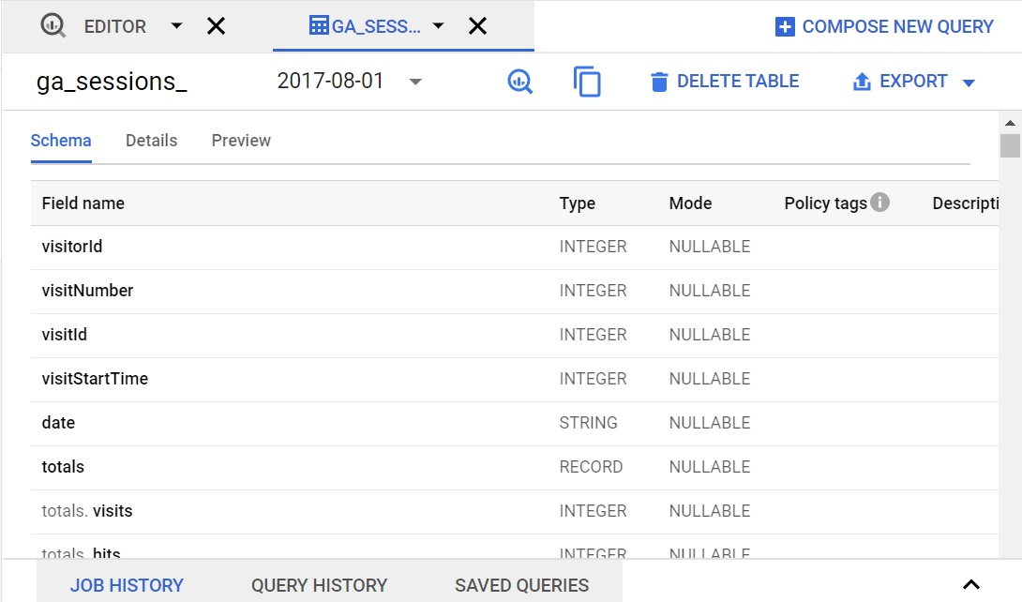

# **SQL Queries**

**Question 1.** What is the average number of transactions per purchaser?

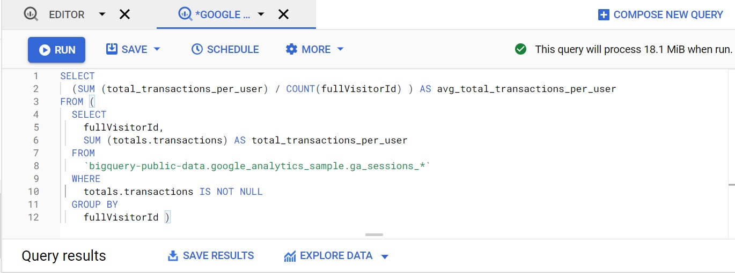

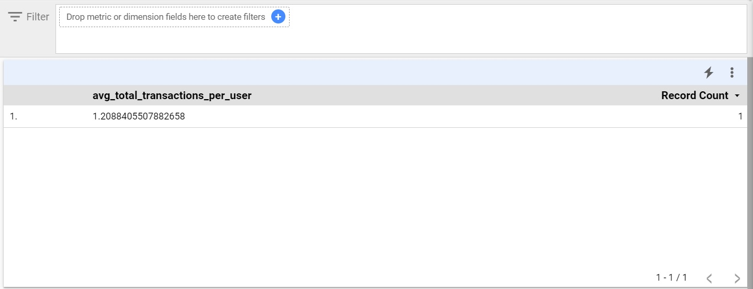

**Question 2.** Calculate the average number of transactions per purchaser for April 2017.

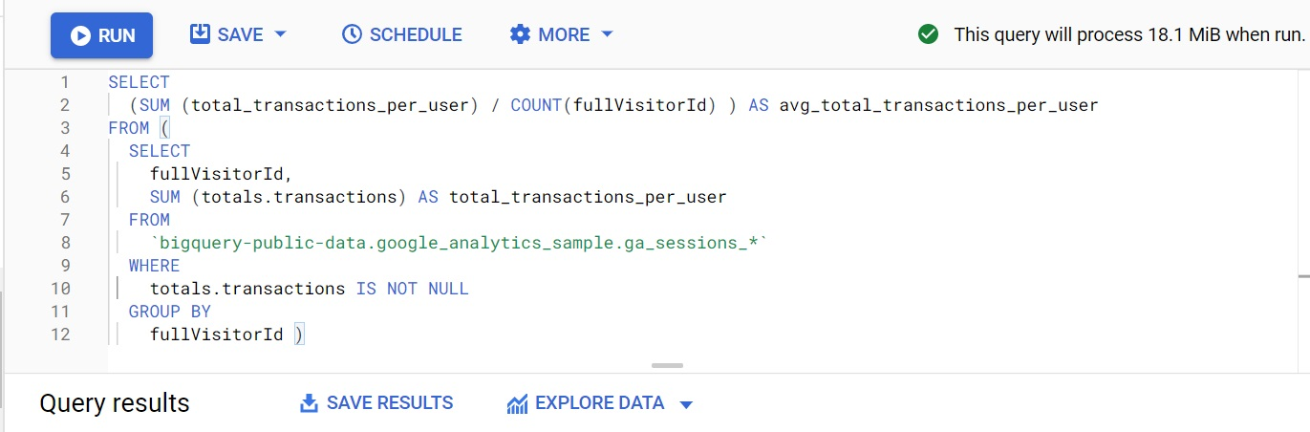

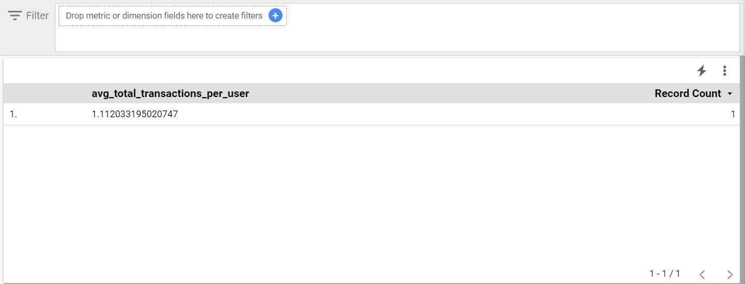

**Question 3.** What is the total number of transactions generated per device browser?

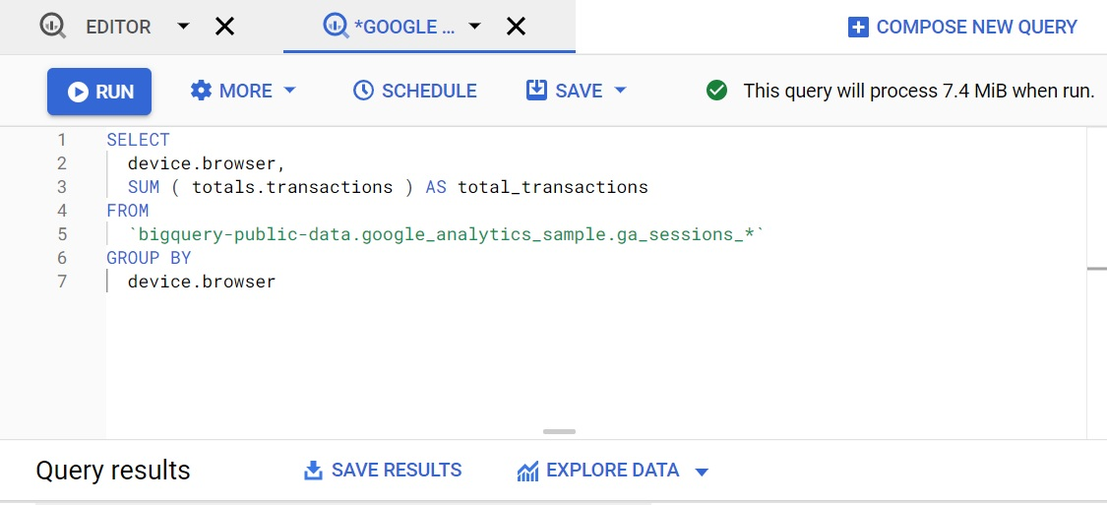

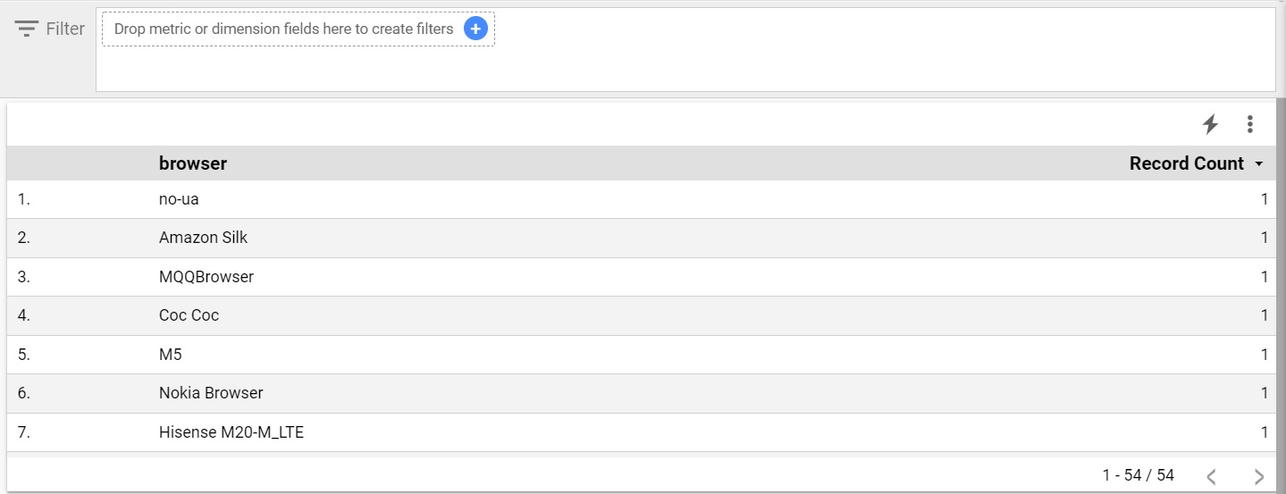

**Question 4.** Identify the top 5 browsers used for making transactions in July 2017, listed in descending order by total transactions.

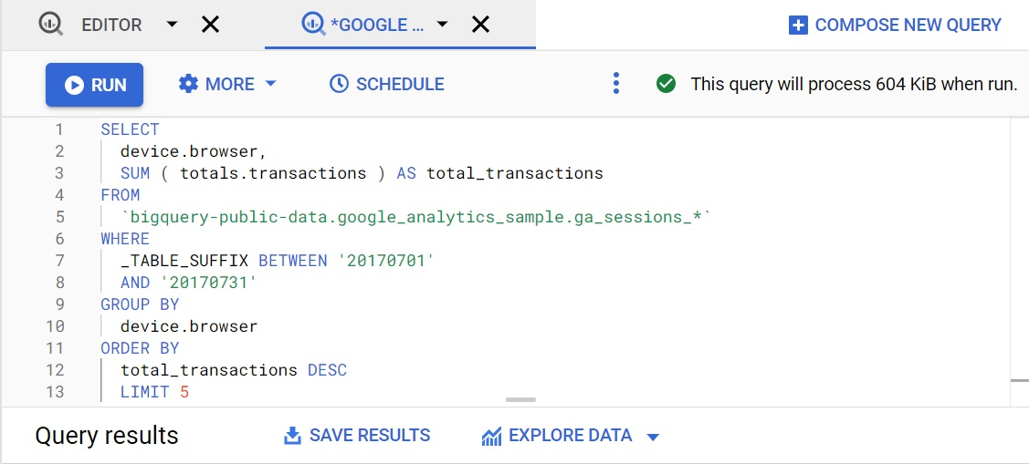

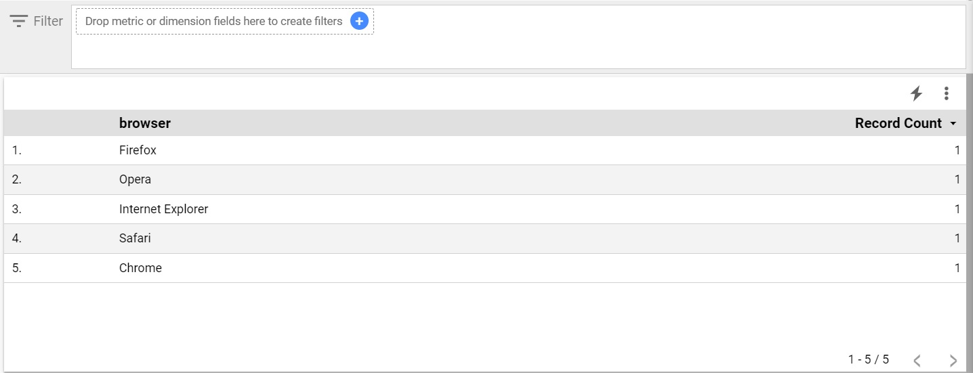

# **3 Lesson Learned**

1. Loading and exporting data: You can quickly load your data into BigQuery. Once BigQuery processes your data, you can export it to analyze it better.
2. Querying and viewing data: BigQuery allows you to run interactive queries. You can also run batch queries and create virtual tables from your data.
3. Managing data: BigQuery allows you to list projects, jobs, datasets, and tables. You can get information about each of these and update or patch your datasets. BigQuery also enables you to delete and manage any data you input

# 